**1.0 User Interface Design**

**1.0.0 Homepage**

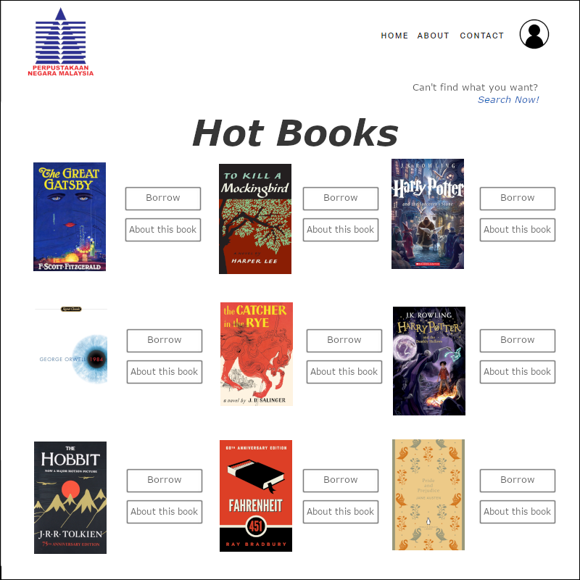Figure 1

The homepage of the library will show some featured books which will be updated every week. A user can click on the “Search Now!” to search a book. User can also click on the people icon on the header to log into the system in order to borrow book. When the borrow button is clicked, user will be directed to the collection date select page. If the user has not log in to the system yet, they will be directed to login page instead.

**1.1 Register**

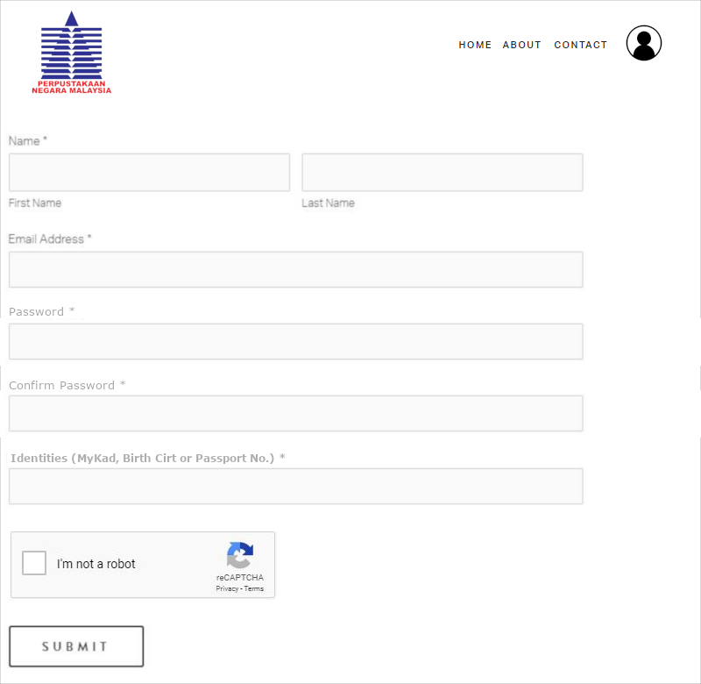Figure 2

If a user wishes to register an account, they will have to enter their information such as first name, last name, email, password and their identities. Malaysian can enter their IC number or Birth Certificate number as their identity and foreigner can enter their passport number as their identity. All account registration must pass the captcha to make sure that the account is not created by a bot. After registration, the system will generate a unique ID for the user.

**1.2 Login**

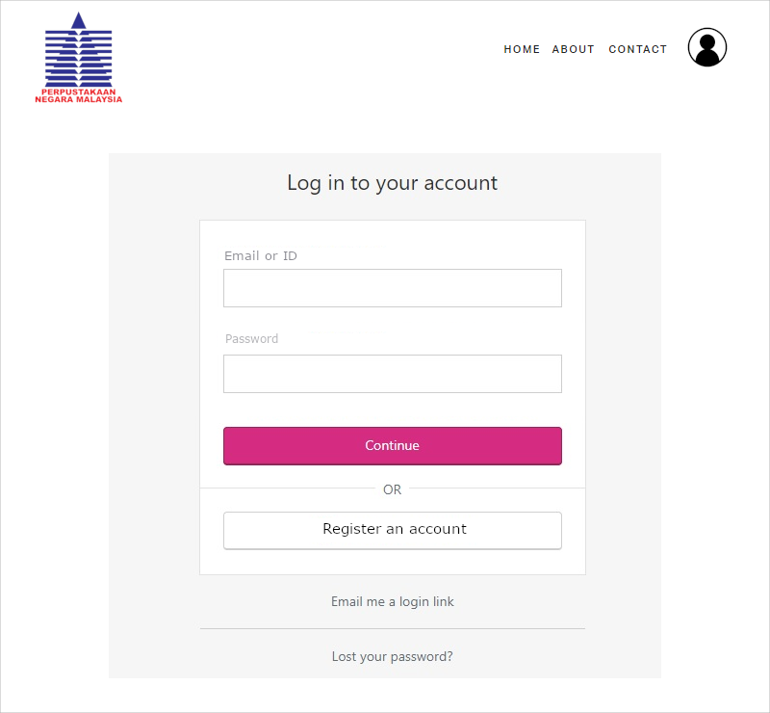Figure 3

If a user already owns an account, they can log into the system by using their email or ID with the matching password. If the user does not have an account yet, the user can click on the register an account button to register a new account. If the user forgot their password, they can click on “Lost your password?” button. After they enter their email or password, the system will send a temporary password to them to log in to the system and then ask them to change their password.

**1.3 Borrow Book**

**1.3.1 Searching**

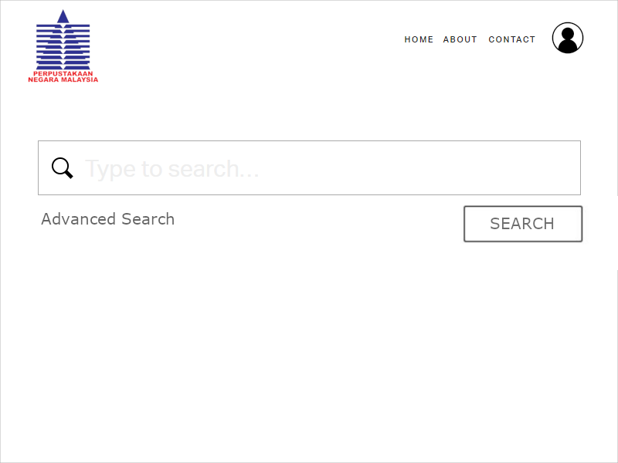Figure 4

A user can type in any details about a book such as its title, language, author, publisher, year of publish to search for a book. They can only enter one of those condition in this page. If they wish to search multiple condition, they can use the advanced search feature provided.

**1.3.1a Advanced Search**

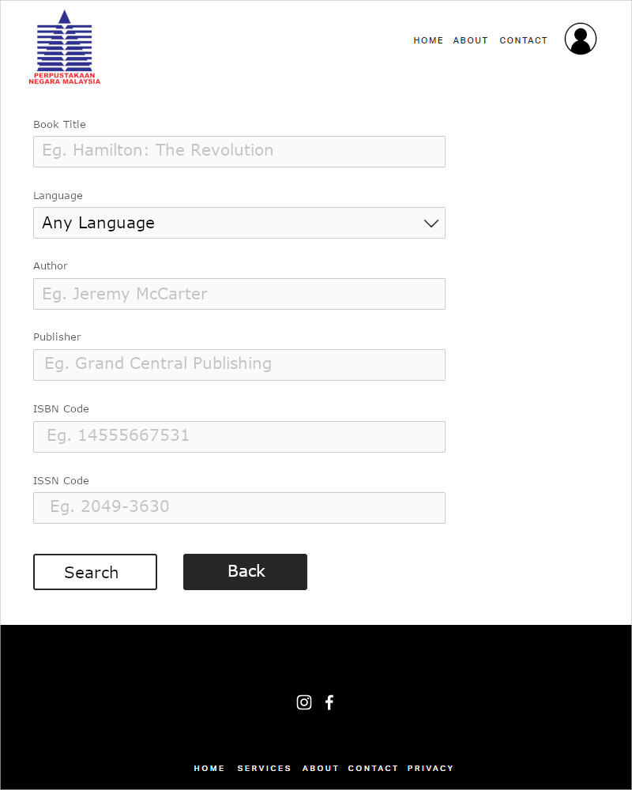Figure 5

**1.3.1b Successful Search**

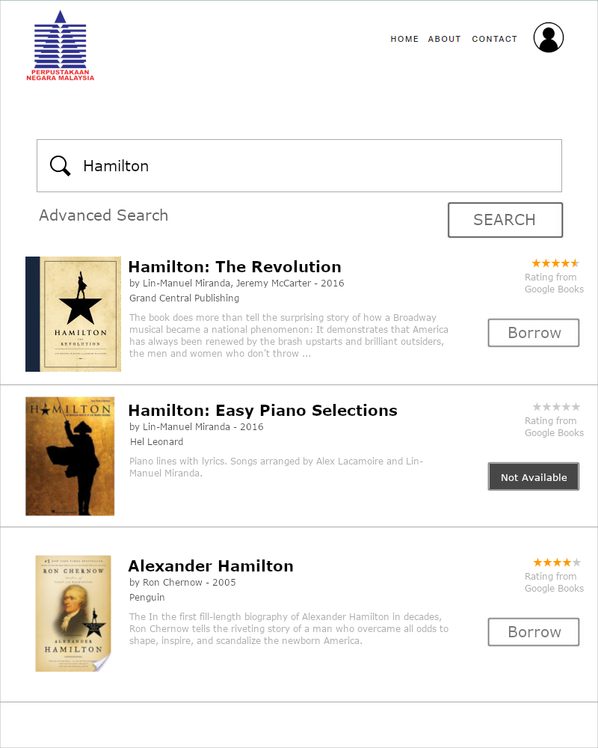Figure 6

After searching, the website will display all books that matches with the searching requirement. This page will show the information such as Book title, author, publisher, and ratings from google books to the user. If a user wishes to borrow any book listed, they can click on the Borrow button if it is available for borrowing. The user can click on the name of the book to get more information of the book.

**1.3.2 Reserving**

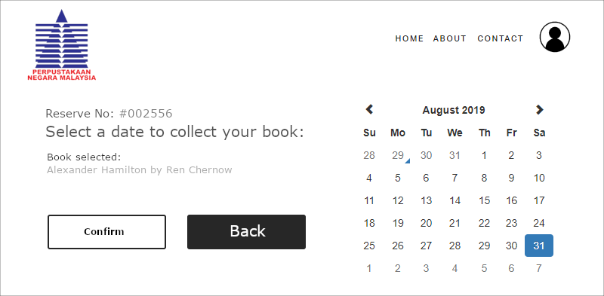Figure 7

After the user click on borrow, the system will ask the user for a date for them to collect their book at the library. This page displays the reserve number, the title of book that the user wants to borrow, and a date selector for the user to select the collection date.

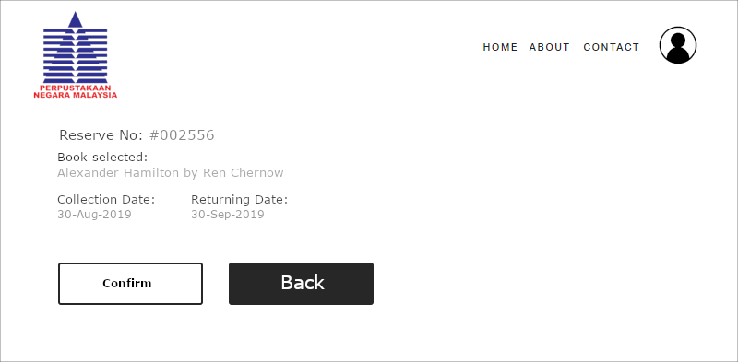Figure 8

After the user select a date, it will display a confirmation message to let the user to confirm if they want that book and will collect it at the day they selected. After this confirmation, the system will generate a receipt for the user to show to the librarian in order to collect the book at that day. If the user does not collect it on the day, the system will consider as the user already return the book.

**1.3.3 Renewing**

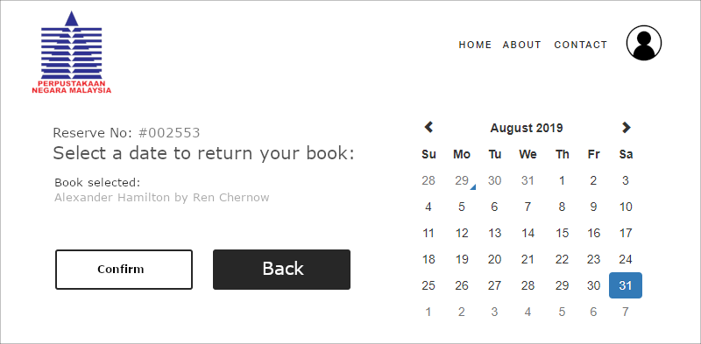Figure 9

A user can choose to renew their book if they requested. A user can select a specific date which is not more than 2 weeks to return their book.

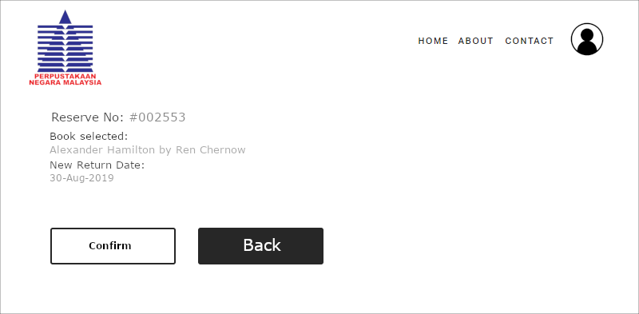Figure 10

Same as the book reserving confirmation, the system will generate a renew receipt for the user after confirmation.

**1.4.0 Returning**

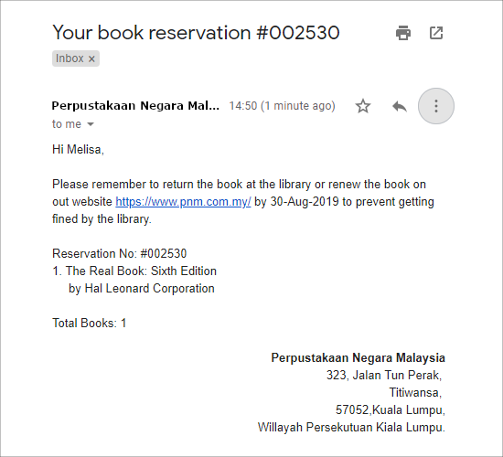Figure 11

A user can only return the book upfront. In this case, our website will not have any option for a user to return their book. This may cause inconvenience to some user but this is the best way to make sure the books are at the best condition. If a book is returned in a bad condition, we can know which user causes that and charge the user for that. The system will automatically generate an email to the user to remind them to return or renew their book to prevent getting fined.

**1.5 Paying Fine**

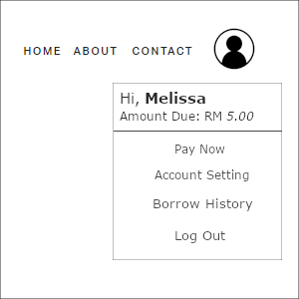Figure 12

When a user clicks on the user icon after they log in, a simple menu that with Pay Now, Account Setting, Borrow History, and Log Out will appear. The “Pay Now” button will not appear if a user does not have any amount due.

**1.5.1 Selecting Payment Option**

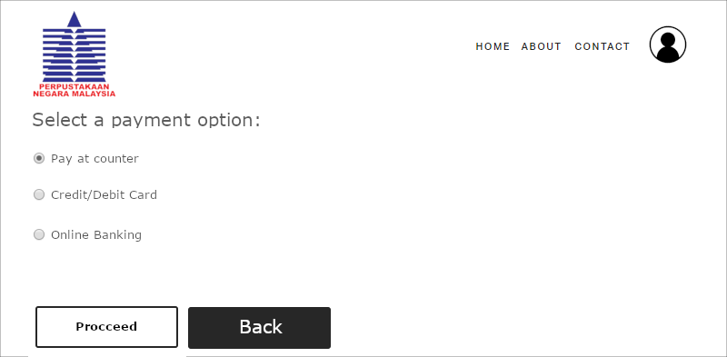Figure 13

After clicking the Pay Now button, the user can choose to pay upfront, by credit/debit card or by online banking. If the user chooses to pay at the counter, the system will generate a bill for the user to print out or store digitally. The user can later show the bill to the librarian to pay for their fines.

**1.5.2 Selecting Banking Option**

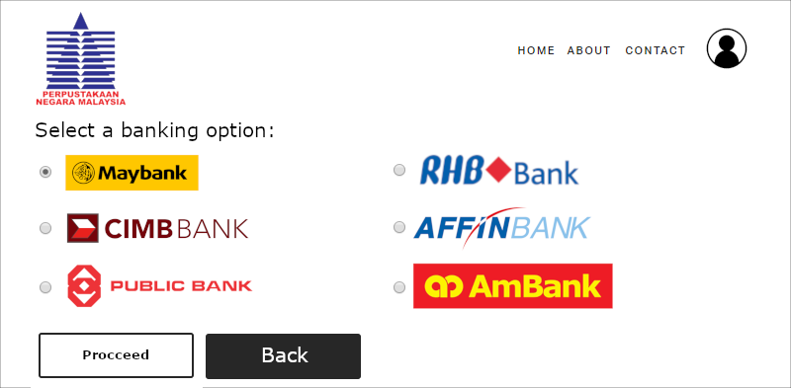Figure 14

If the user chooses to pay by using online banking, they will have to choose their desired online banking bank. They will be directed to the online payment gateway of the bank they selected after they click on the Proceed button.

**1.5.3** **Paying with Credit/Debit Card**

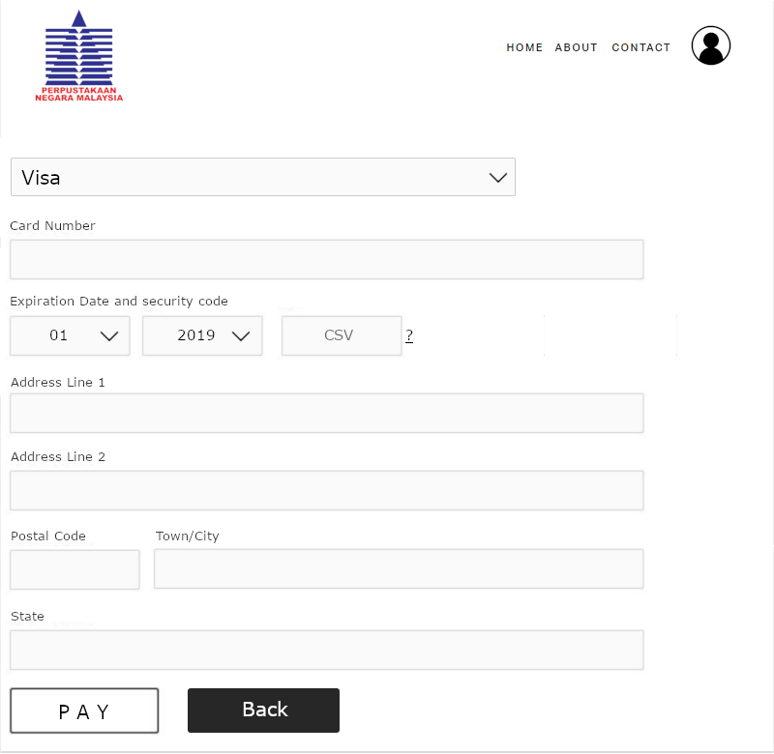Figure 15

If the user chooses to pay with credit/debit card, they will be required to enter information such as card number, card expiration date, CSV and their billing address.

**1.5a Success Payment**

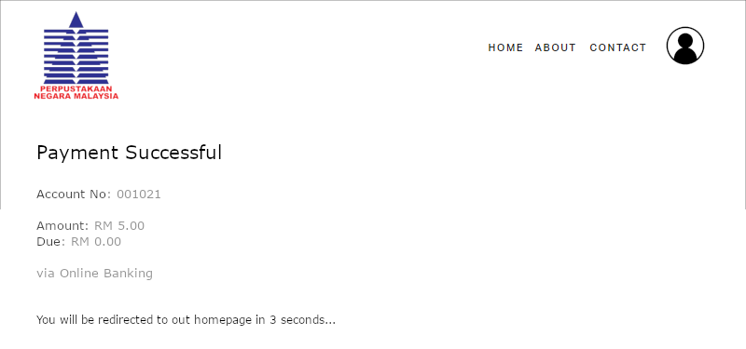Figure 16

The system will show a message if the payment is successful. The message will include information such as account number, amount paid, new amount due, and the payment method. The user will be directed back to homepage after payment. User can check their payment history in their account detail if they have any.

**1.6 Report**

**2.0 Characteristics of User-friendly Interface**

**2.1 Help Facilities**

Figure 5: All the fields obtains a placeholder which guides a user to enter the information that they want. This allow the user to understand more about how to enter the information to search for the book they want. The format of ISBN and ISSN code are provided in the placeholder as well.

**2.2 Escapability**

**Back Button**  
Figure 5: A user can use the back button to go back to the normal search page if they mis-clicked the advance search button or wanted to use back the normal search.  
Figure 7, 8, 9, 10: If a user selected a wrong book or date, they can click on the back button to select another book or date.  
Figure 13, 14, 15: If a user accidentally selected a wrong payment or banking method, they can click on back button to reverse the process or even cancel the payment.

**2.3 Ease of data entry**

Figure 5: A drop-down box is used to select the language of a book to search. Using the drop-down box can make sure the user to not enter other data and can decrease the work of the system by not using data validation to validate the language field input.

Figure 7, 9: A date picker is used to select a date instead of using drop-down or text field. The date picker is more user friendly where it allows a user to see the whole calendar and know which day of the week it is. By using the date picker, the system can right away validate the date entered before clicking the submit.

**2.4 Adherence to industry standards**

The whole process are designed and implemented by using website. A user does not need to download a special software to have access to all those features. Only a browser is needed to access to those features. For the developers, the process of developing the solution is unified as they can only use programming languages specifically for website development.

**3.0 Data Validations**

**3.1 Format Check**

Email

Identity

**3.2 Existence Check**

Book

Email

**3.3 Null Check**

Registration form

**3.4 Data Type Check**

Name

CSV

Postal Code

**3.5 Size Check**

Card Number

CSV

**3.6 Limit Check**

**3.7 Range Check**

**3.8 Check-digit Verification**

Credit/debit card numbers

Registration  
null  
format  
exist  
data  
password check

Login  
exist  
null

Reserving  
range

Returning  
range

Credit/Debit card  
format  
existance  
null  
data  
size  
check-digit